Lab Objective

Learn how to creating a Service Account which is a special type of user account that provides security context for the services running on Windows server OS.

**Lab Procedures**

**1.** Log on to RWDC01 as the **Contoso\administrator** user account with Password, **Password01**. The Server Manager console opens.

**2.** On Server Manager, click Tools > Active Directory Users and Computers.

**3.** In the console tree, expand contoso.com, if needed.

**4.** Right-click contoso.com, click New, and click Organizational Unit. The New Object – Organizational Unit dialog box opens.

**5.** In the Name text box, type **Service Accounts** and click OK.

**6.** Right-click the Service Accounts organizational unit, click New, and then click User. The New Object – User Wizard starts.

**7.** In the First name text box, type **App1**. In the Last name text box, type **Service**. In the User logon name text box, type **App1Service**. Click Next. The password options appear.

**8.** In the Password and Confirm password dialog boxes, type **Password01**. Select the Password never expires option. When a dialog box opens saying that the password should never expire and that the user will not be required to change the password at next logon, click OK.

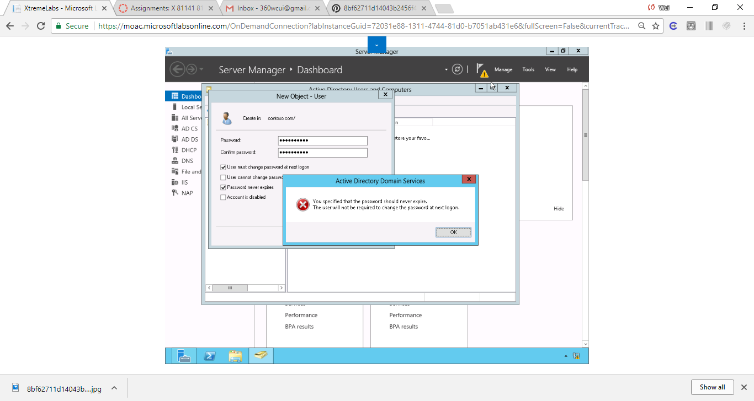

Figure Set the password in the Password and Confirm password dialog boxes. Select the Password never expires option. When a dialog box opens saying that the password should never expire, and that the user will not be required to change the password at next logon.

**9.** Click Next.

**10.** Click Finish to complete creating a service account.

End of exercise. You can leave the windows open for the next exercise.

**Lab Summary**

In this exercise, I created a traditional service account. The Windows operating systems rely on services to run various features. A service account is a user account that explicitly provides a security context for services running on Windows Server OS. The security context determines the service's ability to access local and network resources.